**Nail Salon Management System**

**Deliverable 5 Report: Implementation Phase**

Derek Luong, Thomas Zhang, Spencer Wilkins, Asad Khan, Hamza Mir, Salman Khan

IS 436

Structured System Analysis and Design (04.8331)

**Interface Design Prototypes**

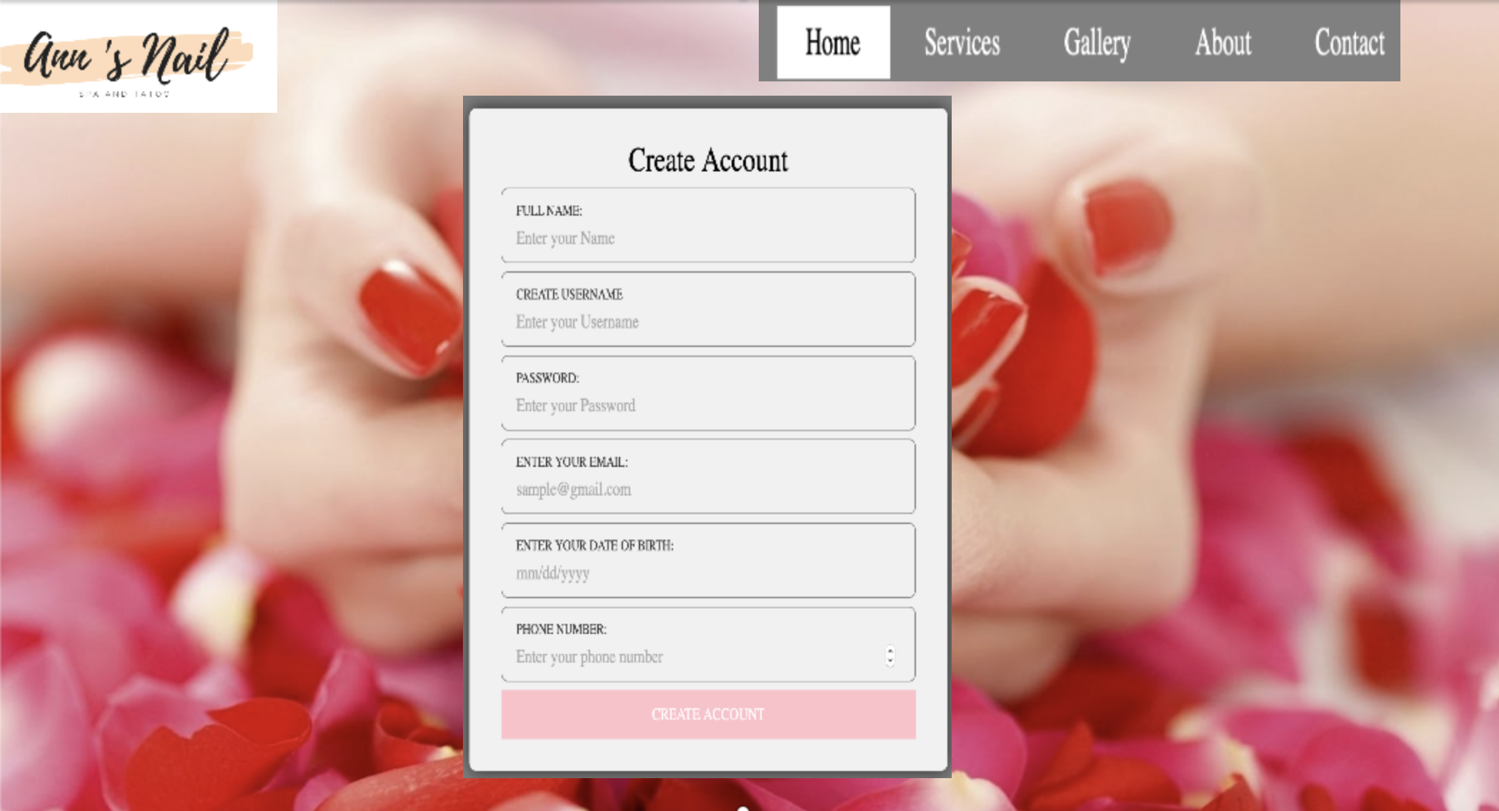

Creating account

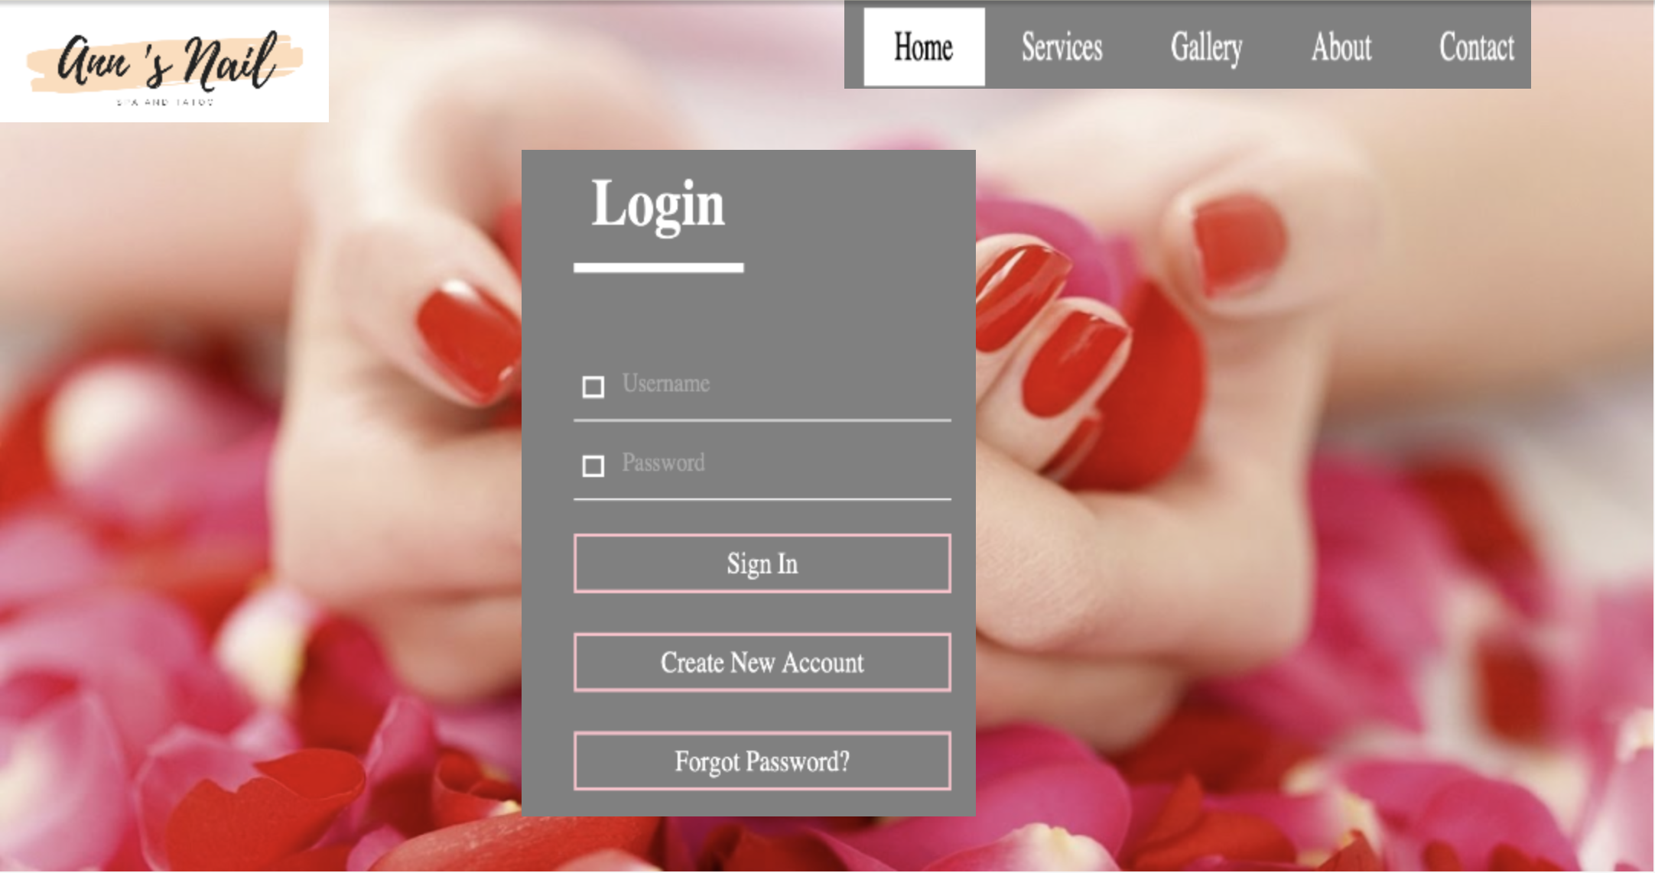

Login



Making Appointment

**Project Plan**

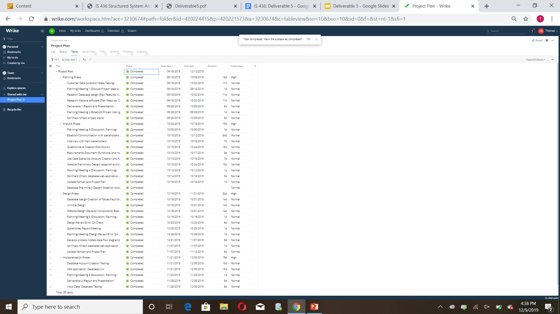

**Kanban**

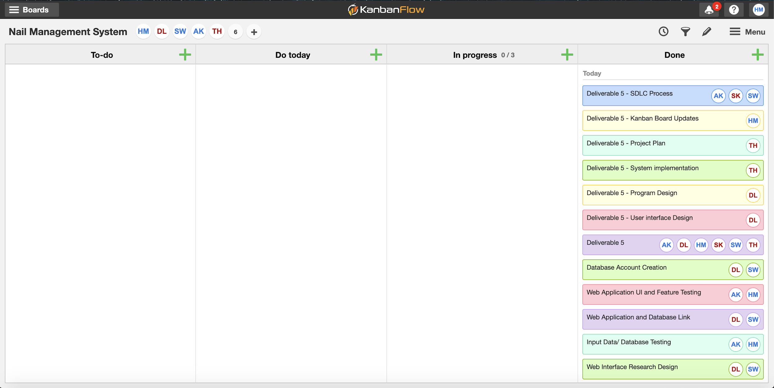

**Explain your team experiences throughout SDLC process. (i.e. rewarding, challenging and how did you solve the challenges as a team)**

**Scheduling Differences:**

We has problems with finding consistent times to meet and complete the project. It was overcome by working and communicating using GroupMe and text so once people saw the updates, they could then take care of their tasks and provide updates. Also maintaining Google Docs / Google Drive so people could access it wherever and whenever.

**Changing Scope of Project:**

Project scope changed after every deliverable, could not come up with one idea and how to do tasks. Worked in small teams and shifted people to help one another and keep each other abreast of the changing developments and up to date on changes and implications. Changed project design, was too difficult initially, limited to 4 use cases.

Overall experience was great for everyone because at first our communication was not strong because we were not familiar with one another. We did not know what was expected of us and how we were going to approach the goal we were going for. However as the project went on we were getting to know each other more and were able to work together strongly and make better decisions as a team.